HW 05 – Interesting API

Selin Eylül Bilen

GitHub: <https://github.com/selinbilen/AudioToText>

YouTube: https://www.youtube.com/watch?v=B9wNnJw_9gs

I made an app named Spext, it is combined of words "speech" and "text". The idea is simple, the app will convert the audio file to the text. I have an audio file of professor Madden’s voice the button will basically load the audio file that I declared in the path* and then will begin the analysis using the Speech framework. It will analyze the audio and then convert it into a text and will drop it in to a UITextField that I have in the application. As API, I used Speech Recognition API.

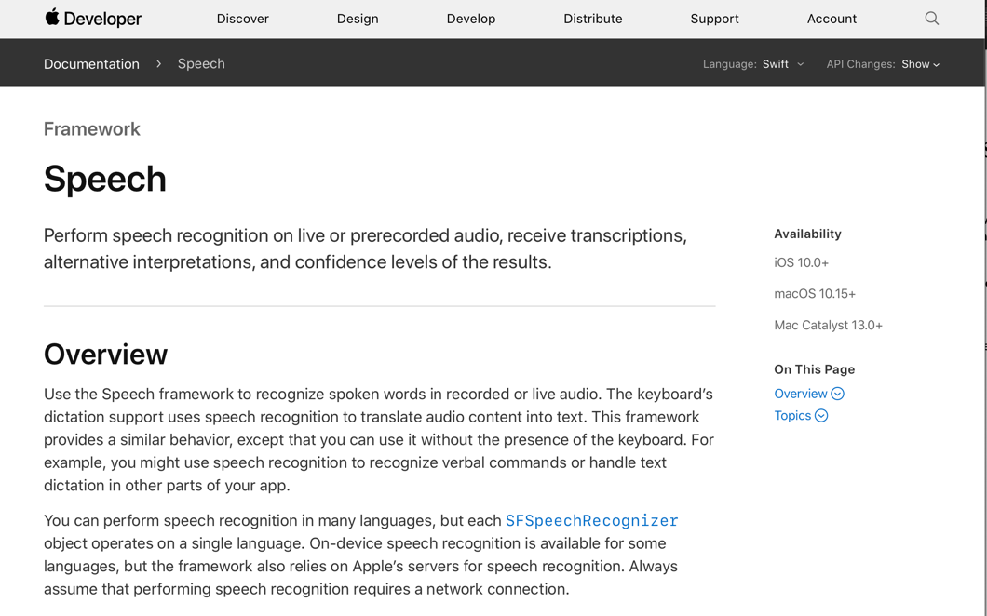

To be able to use Speech framework I needed to get permission so I added the Privacy Key to my Info.plist File.

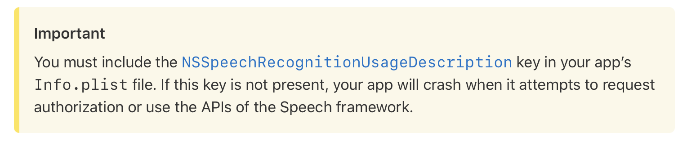

For speech recognition it requires, a recognizer, request, and recognition task. Recognizer basically recognizes there is a speech in the audio, the req will pull the file (*), recognitionTask will put those two together; it will run the file through and then the result will provide that transcription.

